

Business Analysis

Process guide

Contents
1.0 General 2
1.1 Process description 2
1.2 Process overview 2
1.3 Goals and objectives 2
1.4 Scope 2
1.5 Out of scope 3
1.6 Key assumptions 3
1.7 Critical success factors 3
1.8 Integration with other processes 3
2.0 Process 5
2.1 Process activity descriptions 5
2.2 Activity step descriptions 8
3.0 Supplemental Process Information 9
3.1 Key process enablers 9
3.2 Terminology 9
3.3 Key performance indicators 9
3.4 Roles and responsibilities 9
3.5 References 9

- General
  - Process description
The Business Analysis process is responsible for supporting the 1) development of requirements during the initial phases of the software development lifecycle and 2) management of requirements throughout the duration of the lifecycle. Business Analysis identifies business needs and determines solutions to business problems or realization of business opportunities.

  - Process overview
Below is an overview of the Business Analysis process:
S | I | P | O | C
Supplier | Input | Process narrative | Outputs | Customer
- Service Lines  - Service Delivery teams - Markets / CBS / Cross organization | - Defined project  - Approved change  - Project Change Requests | - BA 1.0 - Requirements Development  - BA 2.0 - Requirements Management | - Baseline Requirements  - Impact Assessment | - Service Delivery teams - Markets / CBS / Cross organization  - Strategy & Architecture  - Infrastructure & Operations

  - Goals and objectives
The overarching goal of Business Analysis is to promote the design and build of quality services to enable business processes.
The main objectives of the Business Analysis process are to:
- Plan, estimate and socialize the business analysis approach. This information will be provided to and used by the project manager who is responsible for project planning and monitoring and controlling.
- Identify the business need for the change by understanding the problem the business is trying to solve or the opportunities to improve the business. This may include assessing the current capabilities of the business to support the business need.
- Develop requirements through the elicitation, analysis, specification and verification. This yields multiple levels of requirements in support of the business vision.
- Manage requirements to the appropriate audience throughout the project to ensure all stakeholders have the same understanding and agreement as to the requirements. This implies all conflicts, issues and changes to requirements will be managed to keep everyone informed of the effects of change and the impact on the solution being delivered.

  - Scope
The following are in scope for the Business Analysis process:
- Definition, refinement and capture of business needs in a structured format so that solution can be developed to meet those needs
- Enhancement of requirements that have already been documented

  - Out of scope
The following are out of scope for the Business Analysis process:
- Legacy products lacking a quality requirements baseline
- Commercial-off-the-shelf (COTS) implementations where there is no customization
- Use of an automated requirements management tool

  - Key assumptions
The following key assumptions set some foundation for further process description and design purposes:
- The business analysis role is fulfilled by IT Services individuals skilled in the discipline.
- The change control process is managed outside of BA; however, the impact of the requested change must be accessed through the BA sub-process “manage requirements.”

  - Critical success factors
The main critical success factors (CSF) for the Business Analysis process are:
- Requirements at all levels are understandable, unambiguous and capable of being implemented and tested
- Appropriate business resources are identified and available for elicitation activities
- Due diligence is applied during the sub-process “validate requirements”
- Collaboration with other disciplines throughout the business analysis process
- Requirements are base-lined prior to design and build processes
- Impact assessments are performed prior to processing changes to requirements

  - Integration with other processes
The following tables describe key areas where the Business Analysis process integrates with other processes.
Process | Typical integration points
Program & Project Management | Program and Project Management is used to manage all components of a project to ensure that the project is delivered within the project constraints (scope, schedule, cost, quality, resources and risk) and in support of well-defined objectives and requirements. Program & Project Management provides Business Analysis with a defined project and approved changes. Program and Project Management is responsible for monitoring and controlling the project including business analysis activities during execution. Business Analysis uses defined project information and approved changes to guide the scope of requirements for the proposed solution. As requirements are managed, there may be a need for the Business Analysis process to submit change requests to Program & Project Management.
Design | The Design process is the part of the overall solution development where the primary purpose is to determine how the solution will be implemented. During architecture and design, strategic and tactical decisions are made on how to meet the functional and quality requirements of a solution that were defined during the Business Analysis process.
Application Build | Application Build is the development of a software solution to meet the functional and quality requirements of stakeholders. Application Build uses the baseline requirements along with design documentation to develop the solution. The functional requirements provide details on the required solution functionality while the non-functional requirements govern performance and other quality of service attributes.
Infrastructure Build | Infrastructure Build is the definition and assembly of infrastructure components to meet all levels of requirements for a solution. Business Analysis provides Application and Infrastructure Build with these requirements.
Information Security Management | The Information Security Management process is responsible for managing the organization’s global security framework and ensuring that security requirements are embedded in the overall IT strategy and architecture. Information Security interact with the Business Analysis process by making sure that appropriate security requirements are given to the Business Analysis process and are reflected in the baseline functional and non-functional requirements.
Validation & Testing | The Validation and Testing (V&T) process is responsible for ensuring that the business requirements for software, both functional and non-functional, and the mechanism to deliver that software to customers are met prior to deployment. The Business Analysis process provides the Validation and Testing process with these requirements.

- Process
  - Process activity descriptions
    - Process activity – Wire Diagram

    - Scaling for different types of work
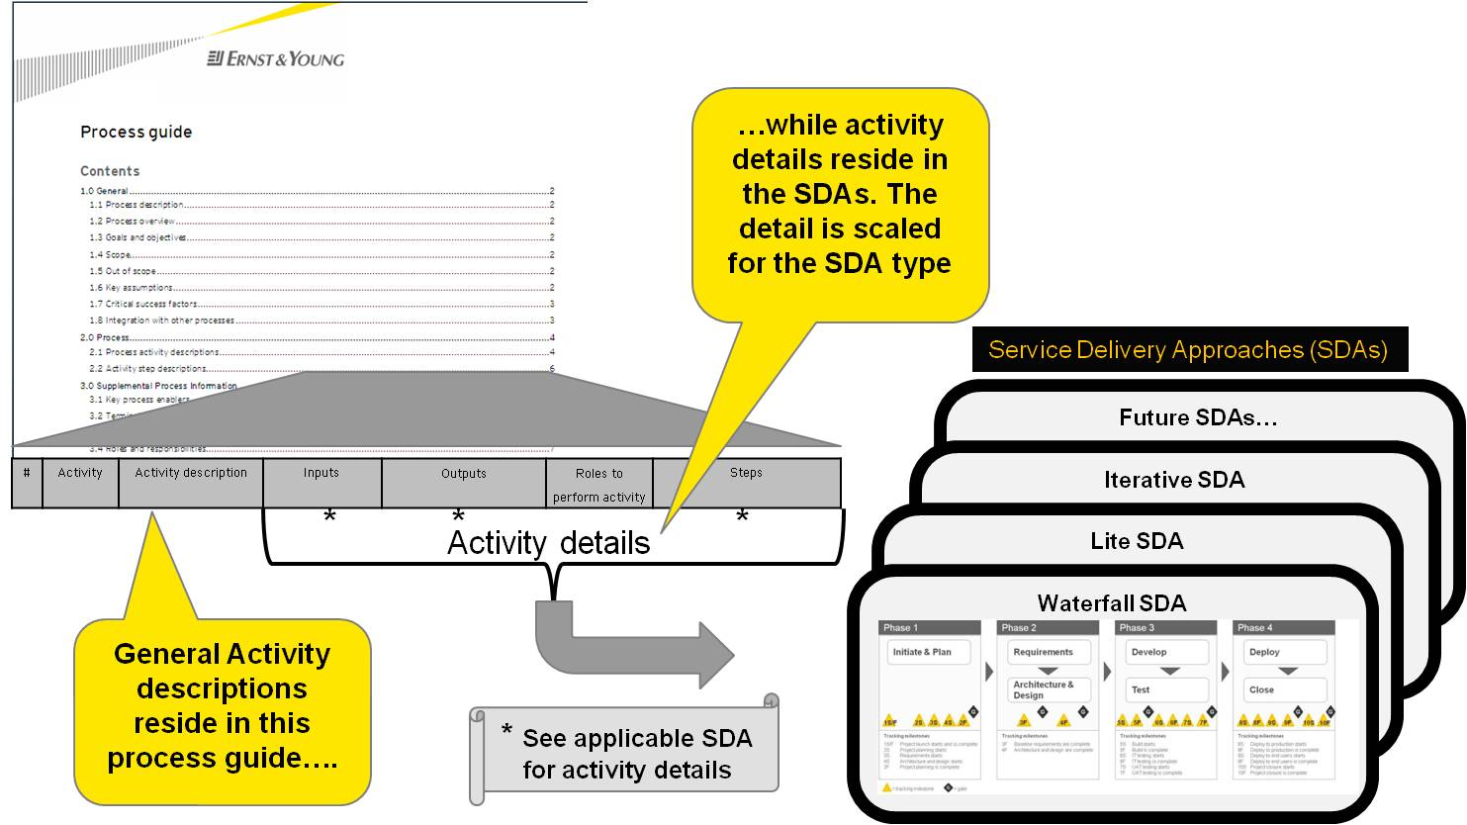

Each process has a structured set of activities that are designed to accomplish an objective. These activities can be detailed down to work instructions that specify exactly what steps to follow to carry out an activity. It is these steps that are scalable and versatile, depending on the type of work being executed. Processes are engaged at different points in a Service Delivery Approach (SDA), which is a technique to document workflow across multiple processes to provide a standard, global approach to delivering a service. Tailoring of the work instructions take place in the SDA to properly scale the process based on project size, complexity, workflow type, etc. and enables each process to be “fit for purpose”. The following activity details (as pictured above) are scaled in the SDAs and highlighted with an " * " in the activity table of this process guide:
- Inputs
- Outputs
- Steps
For example: Roles are identified for each process activity; however, in a smaller project a single individual may fulfill multiple roles. In addition, since the nature of the project will dictate how many people are consulted or informed, the specifics of this information are depicted in each SDA.
ENABLERS - Each SDA will only present the relevant process enablers (templates, etc) for that work type. For example, the Waterfall Lite SDA will only present enablers appropriate for small enhancement type projects. Similar to the work instructions, process enablers will be scaled appropriately and “fit for purpose” to the type of work being executed.

    - Process activity – Details
# | Activity | Activity Description | Inputs* | Outputs* | Roles to perform activity | Steps*
BA-1.1 | Elicit Requirements | Sources of requirements are identified and various elicitation techniques are used to gather requirements from the identified sources. Requirements come from different sources at different times in the lifecycle, have different audiences and purposes and need to be documented in different ways. Several techniques can be used depending on the type of requirement being elicited. |  |  | - Business Analyst
BA-1.2 | Analyze Requirements | Once the information has been elicited, the business analyst refines, analyzes and scrutinizes the gathered requirements to find errors, omissions or other deficiencies. The goal is to develop requirements of sufficient quality and detail to facilitate realistic estimates and proceed with design, build and test. |  |  | - Business Analyst
BA-1.3 | Specify Requirements | After requirements have been elicited and analyzed, the requirements must be documented in a consistent, accessible and reviewable way dependent on the level or class of requirement being documented. Consideration must be given to a standard convention which uniquely identified each requirement yet maintains the traceability of the hierarchical relationship. |  |  | - Business Analyst
BA-1.4 | Verify Requirements | It is necessary to verify all requirement statements to ensure the stated requirements are accurate, complete, meet the desired quality characteristics and will meet the user’s needs. This activity may happen multiple times to facilitate different classes of requirements or multiple requirement packages. |  |  | - Business Analyst
BA-2.1 | Manage Software Requirements | Once business, user and functional requirements have been developed (elicited, analyzed, specified and verified), it is necessary to support the inevitable changes that are requested to software requirements during the lifecycle. While the project change request process is a project management process, it is necessary to evaluate the potential cost and impact of the change to base-lined requirements. |  |  | - Business Analyst
BA-2.2 | Manage Supplemental Requirements | Once supplemental requirements have been developed (elicited, analyzed, specified and verified), it is necessary to support the inevitable changes that are requested to software requirements during the lifecycle. While the project change request process is a project management process, it is necessary to evaluate the potential cost and impact of the change to base-lined requirements. |  |  | - Business Analyst

*For detailed inputs, outputs, and steps, please refer to the specific SDA in the CLEAR tool.

  - Activity step descriptions
Detailed step descriptions and wire frames are not currently defined for this process

- Supplemental Process Information
  - Key process enablers
For a complete list of enablers, please refer to the CLEAR tool.
  - Terminology
All glossary items and/or terminology specific to this process can be found in the IT Services Glossary. Please refer to the link below:
http://glossary.ey.net/itservices/processandservices/glossAll.html

  - Key performance indicators
The following standard key performance indicators (KPI) assess the effectiveness and efficiency of the Business Analysis process and its activities:
Metric | Measurement Formula | Collection Procedure | Frequency | Notes
- % of defects against requirements | - % of defects against requirements | TBD | TBD
- % of time spent on projects developing requirements | - % of time spent on projects developing requirements | TBD | TBD
- % of time spent on projects managing requirements | - % of time spent on projects managing requirements | TBD | TBD
- % of traceability matrix complete | - % of traceability matrix complete | TBD | TBD

  - Roles and responsibilities
    - Role description
Listed below are the key process roles for Design:
Role | Description
Business Analyst | The business analyst is the role primarily responsible for all requirements development and management related activities. The role of a business analyst is a critical project role which interacts directly with the project stakeholders / SMRs and project team to assess the needs to determine what is actually required. In preparation for the requirements gate, the lead business analyst is responsible for verifying all levels of requirements and completing an assessment of the overall requirement quality.

    - Responsibility Matrix
For the responsibility matrix, please refer to the CLEAR tool.
  - References
- IT Services Process Landscape

